38.57: a) Recall 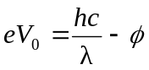
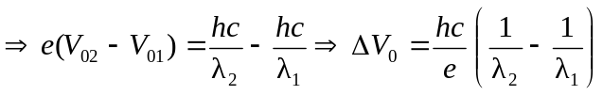
b)
So the change in the stopping potential is an increase of 0.739 V.

